Version 1.0

Revision History

|  |  |  |  |
| --- | --- | --- | --- |
| **Date** | **Version** | **Description** | **Author** |
| 28/12/2019 | 1.0 | Final | Nguyen Khac Phuc |
|  |  |  |  |
|  |  |  |  |
|  |  |  |  |

Table of Contents

1. Change password 4

1.1 Brief Description 4

2. Flow of Events 4

2.1 Basic Flow 4

3. Special Requirements 4

3.1 Valid recent password, new password and confirm new password 4

4. Preconditions 4

5. Postconditions 5

6. Extension Points 5

# Change password

## Brief Description

This use-case defines the step of changing the password of the account corresponding to a user. Users can easily change the password by enter the old password, new password and confirm new password fields.

# Flow of Events

## Basic Flow

-User want to change the password. User clicks the change password button, then the change password view appears with old password, new password and confirm new password fields. Users enter all the fields and click submit button. The system will show message change password success or failed.

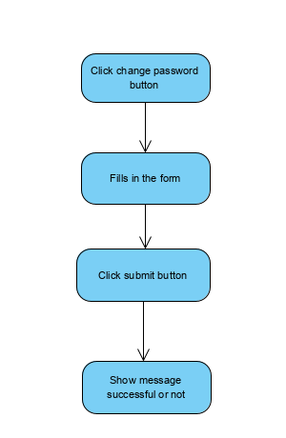

## Actor

- Employee, Accountant

# Special Requirements

## Valid recent password, new password and confirm new password

* Users must enter valid old password, new password and confirm new password

# Preconditions

* User must log in into the system first

# Postconditions

* Show message if change success, the system will show message change successfully or else the system will show message failed

# Extension Points

* No extension points